

MSc in Computer Science - Team Project

Interim Report

**Group 2 – SafePath App**

*More than Navigation, Smarter, Safer journeys*

**Team Members**

D24126339 – Huda Ibrahim

D24127853 – Hina Kausar

D24126048 – Shalini Kuruguntla

D24125575 – Sai Priyanka Basa Shanker

D24125555 – Karan Joseph

**17/10/2025**

Table of Contents

1. Introduction 3

2. User Scenario 4

1.1 Identifying the Target Users 4

**1.1.1** **Personas** 4

**1.1.2** **Collective Insights** 7

1.2 Why They Are Important? 7

3. Technical Problem 13

1. Why SafePath 13

2. Core Technical Problem 15

4. User Interface and Frontend Experience 15

5. Architecture and Deployment 15

6. Data 15

7. Review of Existing Solutions 15

4. Technical Solution 16

5. Evaluation 16

6. Conclusion 16

7. References and Key Resources 16

8. Appendix 17

1.3 1. User Scenario: The Characters (500 words approx.) 18

1.4 2. Technical Problem: The Setting (1,000 words approx.) 18

1.5 3. Technical Solution: The Plot (1,000 words approx.) 18

1.6 4. Evaluation: The Reviews (500 words approx.) 18

1.7 19

1.8 5. Conclusion: The Plan (500 words approx.) 19

1.9 6. References and Key Resources 19

# **Introduction**

The goal of this project is to make a safety-first navigation app for cyclists and walkers that is easy to use, looks good, and works well. The app was first called "SafetyCyclePath" and then changed to "SafePath" to give it a more modern brand identity. We looked at three different logo ideas for the app: (A) a wordmark with pictures of a cyclist and a walker, (B) a shield with a route and a location pin, and (C) a shield with a road and a checkmark. We also chose the colour scheme for the app. After a short UI survey, users said that (Design C) was the clearest and easiest to remember. We then used it as the final logo and made the app's theme match those colours.

**Figure 1 - Logo C**

**Figure 2 - Logo B**

**Figure 3 - Logo A**

The app has a lot of features, such as routing that takes safety into account (Safest / Balanced / Fastest), the ability to report hazards with pictures, buddy matching for shared trips, and map-first browsing with clear, easy-to-understand safety signs.

The goal of the resulting application is to help Vulnerable Road Users (VRUs) feel less anxious when travelling through cities by making it easier for them to make smart decisions about their safety and route planning. We looked at different navigation tools and used survey data to find out what problems everyday cyclists and pedestrians face. This helped us come up with important user-driven features like visible safety ratings, easy-to-use controls for managing route trade-offs, and clear, believable explanations for suggested routes.

The project uses OpenStreetMap OSM data as a base for its road network data. It also includes several London-specific datasets, such as feeds on roadworks and infrastructure updates, available lighting data, publicly available crime figures, and hazards highlighted by the community. These different types of information are turned into map-aligned attributes like infrastructure quality (like protected bike lanes and pedestrian crossings), lighting coverage, the chance of recent incidents (like roadworks or obstructions), environmental risk factors (like rain or wind), and crime exposure levels that change over time. Along with this, user profiles are made where users provide permission to save their routing preferences, saved routes, frequently visited places, and search history. This lets users personalise their experience by choosing things like well-lit streets, calmer routes, or avoiding busy crossings. Users will be able to select and compare routes and get a clear Safety Score for each segment by combining this data. This will give them a useful way to see how safe a route is under the present conditions. The FindBuddy feature, which is optional, will also assist users find friends who are going the same way at the same time. It does this by matching their locations and schedules in a way that keeps their privacy safe.

The main goal of SafePath is to create an easy-to-use online tool that shows routes and safety overlays clearly on both desktop and mobile devices, lets users report hazards, and gives users preset options for the safest, most balanced, and fastest courses.

The MVP puts a high value on clear data, fast interaction, and safety cues that are easy to understand. This goes beyond what traditional navigation applications do and sets the stage for more advanced features like lighting/crime integration, weather modifiers, and buddy matching in future versions.

# **User Scenario**

## **Identifying the Target Users**

SafePath system was designed with a specific goal in mind: to help people who live in cities and deal with safety issues every day to understand it. We used user research, surveys, and persona development to find key categories of vulnerable road users (VRUs) whose experiences contributed to developing the project's vision. The system is aimed at people who live in cities and rely on walking or biking to go around every day, but who have problems with safety, awareness, and infrastructure. Early UX research and surveys found the following key user groups:

### Personas

SafePath primarily serves pedestrians and cyclists in urban areas, particularly those who rely on walking or cycling as a sustainable and cost-effective means of transportation. Personas assist developers and artists understand the types of individuals for whom they are creating content. You don't just consider a general "user." You consider real persons with real requirements. Within this group, we identified five main user categories:

* **University students** and young commuters frequently walk or cycle to class and come home after dark.
* **Working professionals** looking for a safer daily commute can cycle or walk to neighbouring offices or transportation hubs.
* **International residents** and visitors who are unfamiliar with community safety patterns want credible counsel.
* **Community people** can report problems like poor lighting and hazardous crossings to improve public safety data.
* **City planners and local councils** use aggregated reports to improve infrastructure and public safety measures.

As part of the Explore phase, we created three unique personas based on study results, user survey data, and problems:

**Expert Cyclist – Alex Byrne**

A professional software developer and seasoned biker who prioritises efficiency, fitness, and control. Alex exemplifies the performance-driven yet safety-conscious commuter who frequently cycles to work and utilises digital tools to track progress.

* **Goals:** include improving cycling performance, designing safe routes, and reducing reliance on cars.
* **Wants and Needs:** Safe and efficient routes, weather-aware maps, and real-time warnings for accidents and hazards.
* **Pain points** include poor bike lane lighting, imprecise map data, and risky road crossings.

SafePath assists Alex by providing data-driven route ideas, real-time rerouting, and safety heatmaps to enable confident and informed decision-making.

Figure 4 - Persona – Expert Cyclist

**Daily Walker – Eliza Chen**

A retired art curator who takes daily walks for fitness and community connection. Eliza symbolises the active older user who prioritises simplicity, safety, and social belonging.   
**Goals:** Daily walks promote physical and mental well-being, social connection, and safe exploration of the community.   
**Wants and needs** include well-lit walking pathways, easy navigation for low-vision persons, and a simple, intuitive design.   
**Pain points** include poor lighting, difficult route interfaces, and worry over secluded regions.   
SafePath provides Eliza with route visualisations, real-time safety alerts, and easily accessible interface settings (bigger icons, simple layout, high contrast).

Figure 5- Persona – Daily Walker

**Wheelchair Pedestrian – Daniel Murphy**

A library assistant and wheelchair user who values accessibility, freedom, and seamless travel experiences. Daniel symbolises users who have limited physical mobility in typical route planners.

* **Goals:** Use technology to plan accessible and efficient journeys while maintaining confidence and autonomy during travel.
* **Wants and Needs:** Accurate data on curb heights, ramps, and crossings, a smooth app experience, and consistent accessibility upgrades.
* **Pain points** include incomplete accessibility data, insufficient path surface mapping, and a lack of inclusive design in current navigation apps.   
  SafePath offers Daniel accessible route options, audio advice, and community feedback tools for reporting inaccessible places.

Figure 6 - Persona – Wheelchair Pedestrian

### **Collective Insights**

Analysing all three identities, Alex, Eliza, and Daniel, reveals that, despite their disparate lifestyles and abilities, they share several basic needs and expectations. When selecting routes, all users emphasise personal safety and reliability over speed, demonstrating a strong preference for safety-first navigation. Each user prioritises clarity and accessibility in the app's design, which includes readable maps, clear visual cues, and straightforward interactions that reduce confusion while travelling. Another common discovery is the value of community participation; users are motivated to give hazard reports or comments when they see how their contributions improve collective safety. The addition of the "Find a Mate" feature promotes users' desire for social connection and reassurance, especially when travelling at night or in unknown locations. Finally, all personas highlight the importance of reliable, data-driven recommendations—they want a system that appears intelligent, responsive, and credible in offering route options that accurately represent real-world safety situations. These findings support SafePath's objective to build an inclusive, user-centred platform that caters to a variety of needs while encouraging safety, awareness, and confidence in urban mobility.

## Why They Are Important?

These users represent the growing number of people who prefer active, environmentally friendly ways of transportation. While walking and cycling promote sustainability and health, many people avoid them due to perceived or actual risks. Every day, we face unsafe crossings, poorly lit streets, high-crime neighbourhoods, and a lack of riding lanes. SafePath's focus on this diverse, yet safety-conscious demographic directly promotes the aims of urban safety, inclusion, and environmental sustainability.

**UX Research and Surveys**

User survey and data collected by the team revealed that **75 % of respondents preferred safe routes over fast ones**, and **73 % were willing to report hazards**.

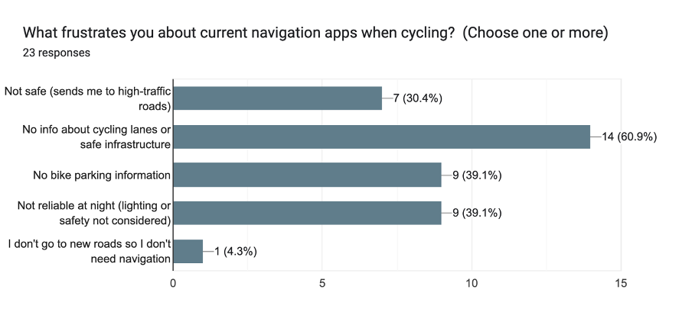

Figure 7- Frustrations about Current Apps

Figure 8 - Valuable Navigation Apps Features

**Key Findings:**

* 91% are beginners or intermediate riders → focus on ease and confidence.
* Top frustrations:
  + Lack of info on cycle lanes/safe infrastructure (61%)
  + Missing bike parking and night safety features (~39%)
* Desired features: real-time hazard alerts, secure parking, and offline data.
* 75% prefer safest routes over fastest.
* 96% would use cycle parking finder.
* 75% open to connecting with others if privacy is protected.

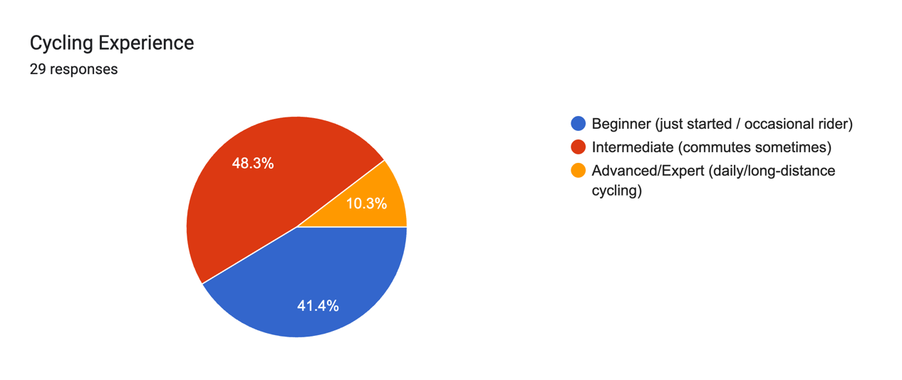

Figure 9- Cycling Experience

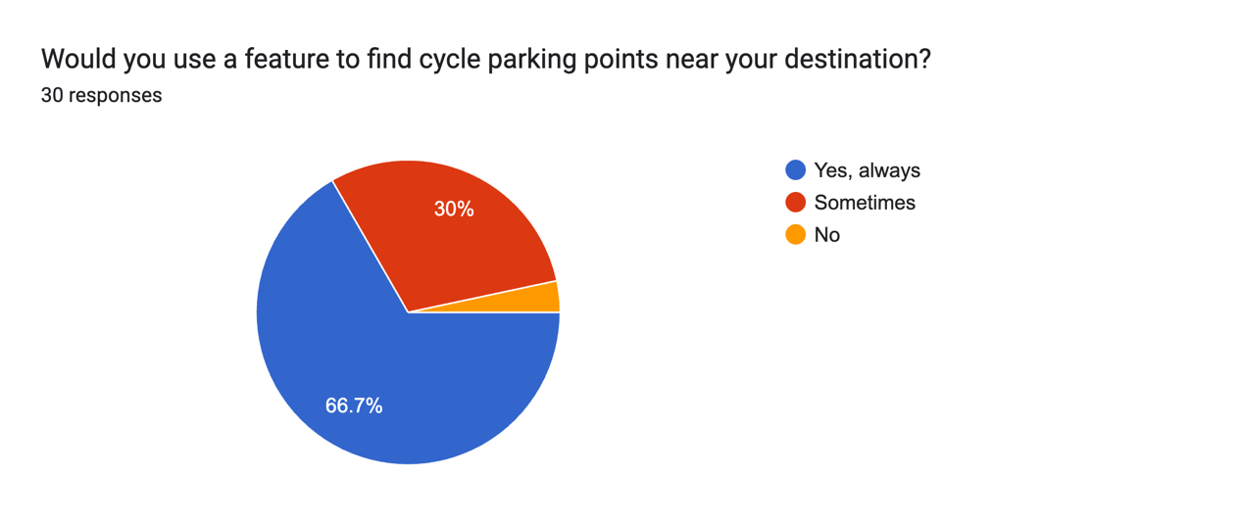

Figure 10 - Pike Park Feature

**Pedestrian Insights (48 responses)**

* Main Takeaways:
* 61% walk daily; walking is part of routine mobility.
* Top frustrations:
  + No hazard alerts (50%), poor lighting info (45%), and lack of safety awareness (39%).
* Most valuable SafePath features:
  + Safe routes (61%)
  + Real-time safety alerts (61%)
  + Safer crossings (50%)
* 85% prefer safe or context-based routes over fastest.
* 100% open to real-time alerts (with smart control).
* 75% open to connecting with walking groups (if privacy protected).
* 73% willing to report hazards, supporting community-driven safety.

Forms response chart. Question title: How often do you walk as part of your daily or weekly routine?

(e.g., to school, work, shops, or transport stops). Number of responses: 48 responses.

Figure 11- Walking Experience

Figure 12 - Reports Hazard Feature

Figure 13 - Find buddy Feature

Figure 14 - User Most Valuable Features

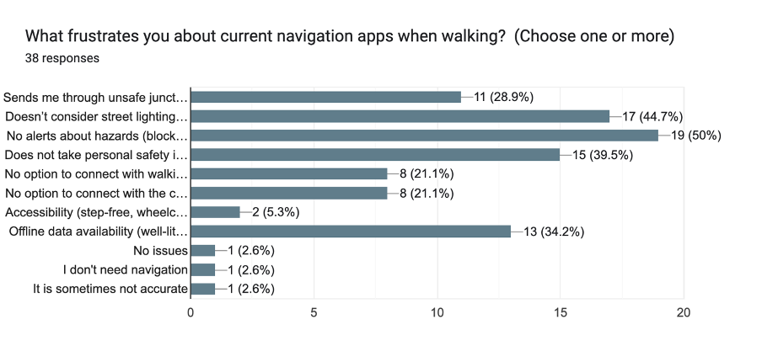

Figure 15 - Current Navigation Apps Experience

Figure 16 - User Interest in App Download

Forms response chart. Question title: How important are these features to you? 

(Rate 1–5: Not Important → Very Important). Number of responses: .

Figure 17 - App Features Importance Diagram

* **Main Takeaways:**
* Preferred **alert type:** non-intrusive — 41% only when app is open, 34% push notifications.
* Most important features: **Safe routes, real-time alerts, offline maps**.
* **59% likely or very likely** to download SafePath; **90% positive or neutral** overall.
* Encouraging factors:
  + **Free to use (82%)**
  + **Unique safety features (52%)**
  + **Trust from local councils or universities (32%)**
* Awareness channels:
  + **Social media (59%)** and **friends’ recommendations (55%)** are key.

These findings confirm strong user motivation for a system that values safety and community participation.

Current navigation apps, such as Google Maps, Waze, and Strava, focus on time and distance rather than safety. They fail to consider real-world facts such as criminal density, lighting quality, and accident frequency. As a result, even the quickest path may expose a pedestrian to hazardous conditions.   
SafePath fills this void by aggregating several datasets—crime, infrastructure, lighting, weather, and user reports—and assigning a Safety Index to each route segment. Users can evaluate the fastest and safest routes and choose based on their comfort and context. The system also promotes friendship with a "Find a Mate" feature that matches users with comparable routes and schedules, improving both physical and psychological safety.

# **Technical Problem**

## **Core Technical Problem**

Figure 18 -Technical Component Diagram

The idea for this app went through multiple iterations before the current format was finalised. Starting from discovering suitable datasets for urban mobility, first for pedestrians, then for cyclists. We iterated on feasibility and coverage and ultimately combined both to serve mixed-mode users. The concept of a safety-first routing application, SafePath combining hazard-aware navigation with an optional buddy feature was chosen for a variety of reasons.

SafePath covers a common gap we found in our competitive analysis with the help of this app comparison article(Portus, 2024). It says that most navigation tools, even those made for cycling, only focus on time or distance, with little thought given to personal safety (for example, they only have "quiet" or surface-type filters). This means that people who walk and ride bikes have to figure out how to stay safe on their own instead of using evidence-based risk models. This disparity is essential since the environment and infrastructure have a clear effect on how likely it is that bikers and pedestrians may get hurt. For instance, having protected or separated facilities, well-designed streets, and enough light all make people less likely to get hurt and more likely to walk or cycle (Reynolds et al., 2009)(Teschke et al., 2012)(Vidal-Tortosa & Lovelace, 2024).

Figure 19 - Competitive Analysis Sample

Our user research supports this reason. The interview guide focusses on the interface's readability, the user's perception of safety, and their expectations for features like "Find Buddy." These are exactly the areas where current services don't do enough for vulnerable road users (VRUs). The survey was given to students, engineers, healthcare workers, teachers, and other people in the community. This shows that there is a lot of interest in safe, everyday cycling beyond just sport riders.

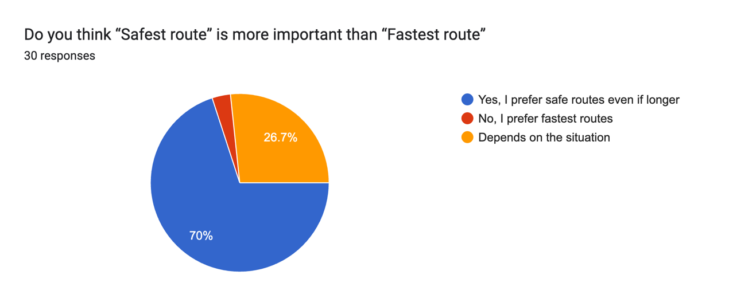

Figure 20- Safest vs Fastest

Research indicates that "near misses" are common and provide insights into risk, yet are never included in official datasets; crowdsourced reporting can address this gap(Nelson et al., 2015)(Branion-Calles et al., 2017). Adding community hazard reports to official feeds is not simply a nice-to-have feature; it is critical for safe routing.

Finally, safety situations change all the time. Patterns in the weather, visibility, and time of day change the level of danger; for example, rain, low visibility, and peaks all raise the risk of a crash, and changes in the weather change the number of cyclists and the chance of an accident(Myhrmann & Mabit, 2023)(Pazdan, 2020). A static "fastest route" model can't deal with these changing exposures; SafePath's purpose is to do so.

## **User Interface and Frontend Experience**

## **Architecture and Deployment**

## **Data**

## **Review of Existing Solutions**

# **Technical Solution**

# **Evaluation**

# **Conclusion**

# **References and Key Resources**

1. Branion-Calles, M., Nelson, T., & Winters, M. (2017). Comparing Crowdsourced Near-Miss and Collision Cycling Data and Official Bike Safety Reporting. *Transportation Research Record*, *2662*(1), 1–11. https://doi.org/10.3141/2662-01
2. Myhrmann, M. S., & Mabit, S. E. (2023). Assessing bicycle crash risks controlling for detailed exposure: A Copenhagen case study. *Accident Analysis & Prevention*, *192*, 107226. https://doi.org/10.1016/j.aap.2023.107226
3. Nelson, T. A., Denouden, T., Jestico, B., Laberee, K., & Winters, M. (2015). BikeMaps.org: A Global Tool for Collision and Near Miss Mapping. *Frontiers in Public Health*, *3*. https://doi.org/10.3389/fpubh.2015.00053
4. Pazdan, S. (2020). The impact of weather on bicycle risk exposure. *Archives of Transport*, *56*(4), 89–105. https://doi.org/10.5604/01.3001.0014.5629
5. Portus, S. (2024, July 24). *Best cycling apps 2025 | 19 iPhone and Android apps for cyclists*. BikeRadar. https://www.bikeradar.com/advice/buyers-guides/best-cycling-apps
6. Reynolds, C. C., Harris, M. A., Teschke, K., Cripton, P. A., & Winters, M. (2009). The impact of transportation infrastructure on bicycling injuries and crashes: A review of the literature. *Environmental Health*, *8*, 47. https://doi.org/10.1186/1476-069X-8-47
7. Teschke, K., Harris, M. A., Reynolds, C. C. O., Winters, M., Babul, S., Chipman, M., Cusimano, M. D., Brubacher, J. R., Hunte, G., Friedman, S. M., Monro, M., Shen, H., Vernich, L., & Cripton, P. A. (2012). Route Infrastructure and the Risk of Injuries to Bicyclists: A Case-Crossover Study. *American Journal of Public Health*, *102*(12), 2336–2343. https://doi.org/10.2105/AJPH.2012.300762
8. Vidal-Tortosa, E., & Lovelace, R. (2024). Road lighting and cycling: A review of the academic literature and policy guidelines. *Journal of Cycling and Micromobility Research*, *2*, 100008. https://doi.org/10.1016/j.jcmr.2023.100008

# **Appendix**

## 1. User Scenario: The Characters (500 words approx.)

* Who is your target user?
* Why are they important?
* What problem are you solving for them?

## 2. Technical Problem: The Setting (1,000 words approx.)

* Why does your system exist?
* What is the core technical problem? (provide an example, an image or a diagram that describes the technical components)
* Can you review other existing systems or products that address this problem? (how do they meet or fail to meet the needs of your target users)

## 3. Technical Solution: The Plot (1,000 words approx.)

* What does your system do?
* How does it work? (System diagram)
* Front-end: Technologies, User interface components including interface mock-ups
* Back-end: Technical components
* Data: What data resources are you going to use and how will you access, collect, and store them?

## 4. Evaluation: The Reviews (500 words approx.)

* What does success look like for your system?
* How will you evaluate the system that you built?

## 

## 5. Conclusion: The Plan (500 words approx.)

* What is your project management strategy?
* What are the biggest challenges you are currently facing?
* How will you use the time remaining to achieve a successful outcome?

## 6. References and Key Resources

* List of resources (software, papers, tutorials, books, stats, business indicators)